SMART WASTE MANAGEMENT SYSTEM FOR METROPOLITAN CITIES

**TEAM ID:** PNT2022TMID19565

# INTRODUCTION

## Project Overview:

Extensive disposal of waste is a major issue in metropolitan cities of most developing countries and it causes severe threat to people. Access to reliable data on the state of waste at different locations within the metropolitan cities will help both the local authorities and the citizens to effectively manage the wastes. In this paper, an intelligent Smart Waste Management system is developed using IBM Watson IoT platform and cloud computing technologies. The fill level of waste in each of the garbage bins, which are monitored through a web App. The weight of the garbage has been measured. It alerts an authorized person to empty the bin when they are filled. GPS is used to transmit the sensor data to an IoT cloud platform. The system performance shows that the proposed solution may be found useful for efficient waste management in smart and connected communities.

## Purpose:

Using technology and innovation to optimize current systems will enable cities to become smarter, more efficient and save resources. Due to the growing population, the amount of waste being produced is vast and rapidly increasing. The management of this waste is therefore a significant area for much-needed improvement.

Currently, waste collection systems are in most cases outdated and result in pick-ups that are unnecessary or on the contrary – long-overdue. Unnecessary pickups result in 70% higher annual collection cost. When routes are planned inefficiently, congestion is created more fuel is required to complete the collection. Overall, this contributes to a 50% higher carbon footprint.

With the use of IoT solutions for waste management, these issues can be solved by creating a more efficient pathway for garbage trucks. IoT sensor technology can be used to indicate when the

emptying is actually needed. This customized and dynamic system for waste management can allow businesses, organizations, and citizens to all benefit.

# LITERATURE SURVEY:

## Existing problem:

Waste management has become an alarming challenge in local towns and cities across the world. Often the local area bins are overflowing and the municipalities are not aware of it. Thisaffects the residents of that particular area in numerous ways starting from bad odour to unhygienic and unsafe surroundings. Poor waste management - ranging from non-existing collection systems to ineffective disposal -causes air pollution, water and soil contamination. Open and unsanitary areas contribute to contamination of drinking water and can cause infection and transmit diseases. Toxic components such as Persistent Organic Pollutants (POPs) pose particularly significant risks to human health and the environment as theyaccumulate through the food chain. Animals eating contaminated plants have higher doses of contaminants than if they were directly exposed. Precipitation or surface water seeping through waste will absorb hazardous components from landfills, agricultural areas, feedlots, etc. and carry them into surface and groundwater. Contaminated groundwater also poses a great health risk, as it is often used for drinking, bathing and recreation, as well as in agricultural and industrial activities. Landfills and waste transfer stations can attract various pests (insects, rodents, gulls, etc.) that look for food from waste. These pests can spread diseases through viruses and bacteria (i.e., salmonella and e-coli), which are a risk to human health.

## References:

**PAPER 1:**

**AUTHOR NAME:** Nadia Puspita Adriyanti

## DESCRIPTION:

Waste has always been a serious problem, not only to the environment but also to the economic and social aspect. Solid waste management models are created to solve waste problems in different aspects and areas. Many models were made to tackle waste problems in cities or metropolitan areas. Yet, there are no specific solid waste management models that are made specifically for villages that undergo a transition to a city and it is affecting both natural and social environment in the area. A literature study was done to see which existing model could be applied to Indonesia's transitioning villages through the lenses of sustainable urban planning by reviewing ten existing models.

## PAPER 2:

**AUTHOR NAME:** Chaware

## DESCRIPTION:

He proposed a waste get-together structure considered imaginative to help with keeping urban domains clean. The structure works by watching rubbish stores and tell the experts and the waste collection vehicles about the part of garbage set away or contained in the reject holder through a web application. Regardless, the framework utilizes ultrasonic sensors in which theirdistinctive precision can be affected by changes in temperature. Besides, it utilizes Wi-Fi which is inherently ashort-range alliance instrument. From this time forward, these disadvantages sway the ideal execution of the structure.

## PAPER 3:

**AUTHOR NAME:** Kumar

## DESCRIPTION:

In their work proposed an IOT based unbelievable waste clean association structure where sensor frameworks are utilized to steadily checking the waste component of the garbage canisters. In this methodology, when the waste estimation over the dustbins is recognized, the framework along these lines cautions the embraced individual by strategies for GSM/GPRS. The structure works by utilizing a microcontroller which gives interface between the sensor and the GSM/GPRS framework.

Also, an Android application is utilized to screen and join the important data identifying with the unmistakable component of waste found in various zones. With this framework, another client can choose the structure and not simply the manager. Regardless, anybody can make a record and the framework likewise surrender access to clients not expected for. This framework can be improved by setting two holders to self-rulingly collect dry and wet squanders. For this situation, the wet waste can be moreover masterminded and be utilized for the period of biogas, made intense by making it insignificant and fiscally astute

## PAPER 4:

**AUTHOR NAME:** Ruhin Mary Saji

## DESCRIPTION:

The level of garbage in the bin is detected by using the ultrasonic sensor and communicates to the control room using the GSM system. Four IR sensors are used to detect the level of the garbage bin. When the bin is full the output of the fourth IR is active low and this output is given to the microcontroller to send a message to the control room through GSM In this paper ZigBee, GSM and ARM7 controller is used to monitor the garbage bin level. When the garbage bin is full, this message of garbage level is sent to the ARM7 controller. Then ARM7 will send the SMS through GSM to authority as to which bin is overflowing and requires cleaning up.

## PAPER 5:

**AUTHOR NAME:** Talyan

## DESCRIPTION:

Talking about the municipal solid waste management in Delhi, how it is implemented in Delhi, its current practices, by the local government.

Then how in the solid waste management NGO‟s and community people are involved in Delhi that is mentioned in this article?

Also mentioned the policy legislative framework of SWM in India. Then over the year how the composition and generation of SWM happened in India that is mentioned in this article, then it is mentioned the composition, recycling, transportation how and which was happening in the Delhi and at last it explains the initiatives towards managing the best practices of MSWM (Municipal Solid waste management) by Delhi municipal corporation. In conclusion, they are explaining that the Municipal Corporation of Delhi has taken big steps to the improvement of SWM in Delhi also frame the guideline (2015-2021) as a master plan.

* 1. **Problem Statement Definition:**

|  |  |  |  |  |  |
| --- | --- | --- | --- | --- | --- |
| **Problem Statement (PS)** | **I am (Customer)** | **I am tryingto** | **But** | **Because** | **Which makes me feel** |
| PS-1 | Council | control over spilled waste containers giving off irritating smells causing serious health issues and atmosphere  impairment. | municipalities have a hard time keeping up with these outdoor bins | Because it is very difficult to figure out when to empty them or whether they are full or not at all. | to propose a real time project on waste management to save the city and the people |
| PS-2 | Council | Manage the waste in my city | I have not much effective system for managing | Because of more time consuming | unsafe |

# IDEATION & PROPOSED SOLUTION:

## Empathy map canvas:

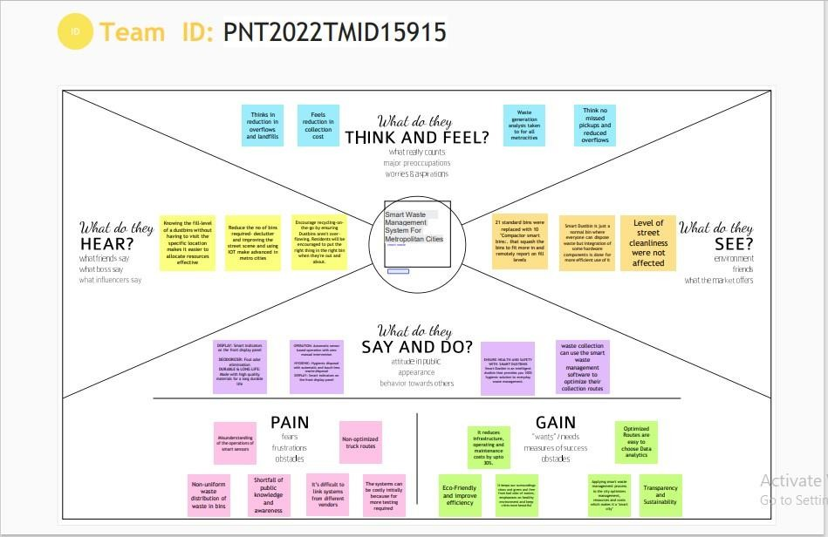

* 1. **Ideation & Brainstorming:**

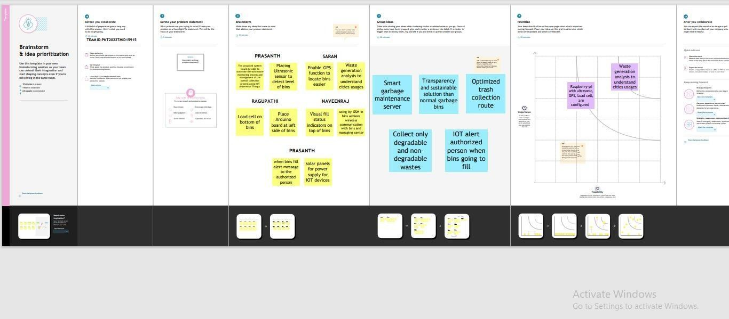

## Proposed Solution:

|  |  |  |
| --- | --- | --- |
| **SI No.** | **Parameter** | **Description** |
| 1. | Problem Statement (Problem to be solved) | Rubbish and waste can cause air and water pollution.  Rotting garbage is also known to produce harmful gases mix with the air and cause breathing problem in people.  Due to improper waste disposal, we may face  several problems like unpleasant odour and health problems. |
| 2. | Idea / Solution description | To solve this problem of waste management for disposal using a smart refuse bin built with technologies like Sensors, Arduino Yun. Garbage truck Weighing Mechanisms.  AI Recycling Robots. |
| 3. | Novelty / Uniqueness | Identify potential waste streams. Create a waste management-focused community outreach plane. |
| 4. | Social Impact / Customer Satisfaction | Neighbourhood of landfills to communities, breeding of pests and loss in property values. The IOT solution uses the data and selects optimum routes for waste collection trucks. |
| 5. | Business Model (Revenue Model) | It generates revenue through the provision of various waste management and disposal services.  Recycling solutions to  residential,commercial,industrial,and municipal clients |
| 6. | Scalability of the Solution | Installing more bins fir collecting recyclables like paper, glass,plastice.  Recycling not only save energy but also prevent the material from going to landfills & Incineration and provides raw materials for new products. |

* 1. **Problem solution fit:**

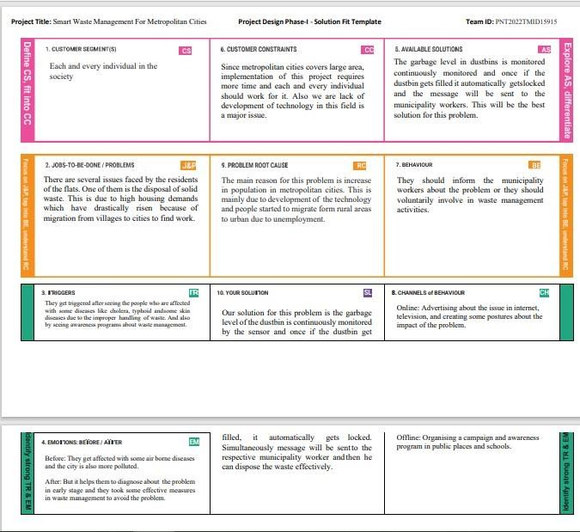

# REQUIREMENT ANALYSIS

## Functional requirement

|  |  |  |
| --- | --- | --- |
| **FR No.** | **Functional Requirement (Epic)** | **Sub Requirement (Story / Sub-Task)** |
| FR-1 | User Registration. | Registration through Form Registration through Gmail |
| FR-2 | User Confirmation | Confirmation via Email Confirmation via OTP |
| FR-3 | Bin Invention | The proposed model provide real time monitoring to the garbage bins placed in various location. You can see every monitored bin and stand, and you can use google street view at any time to visit them. |
| FR-4 | Bin Monitoring | The Garbage bins are monitored by smart sensors. the application also forecasts when the bin will be filled based on the past data and capacity of the bin. The sensor will know when the bin was last emptied.So,you can eliminate overflowing bins and cease collecting the empty ones. |
| FR-5 | Notification | The percentage of garbage level will be detected through sensors. When the garbage level is increased above 75%,it gives notificatiion to the security team. After receiving the notification,the garbage collector collects the garbage. |
| FR-6 | Optimize the route to collect | Waste collectors will use their time effectively by collecting the wastes which requires service rather than travelling the same routes . |
| FR-7 | Database | Information about the location and status of bins will be stored in the database. |
| FR-8 | Feedback | It helps the developer to improve the apps. |

* 1. **Non-Functional requirements:**

|  |  |  |
| --- | --- | --- |
| **FR No.** | **Non-Functional Requirement** | **Description** |
| NFR-1 | **Usability** | To study the customers product usability can help desiners to understand better. |
| NFR-2 | **Security** | Security is enhanced as the system has a secured login/registration page and even the data is stored in a secured manner. |
| NFR-3 | **Reliability** | The user can access the bin level and location of bin and update the status of each bin. |

|  |  |  |
| --- | --- | --- |
| NFR-4 | **Performance** | It has better performance by optimizing the routes. |
| NFR-5 | **Availability** | The entire system is available for all the time when reqiures. |
| NFR-6 | **Scalability** | Using smart bins may reduce the number of bins inside the cities because we monitor the garbage 24/7 more efficient. |

# PROJECT DESIGN:

## Data Flow Diagrams:

A Data Flow Diagram (DFD) is a traditional visual representation of the information flows within a system. A neat and clear DFD can depict the right amount of the system requirement graphically. It shows how data enters and leaves the system, what changes the information, and where data is stored A smart waste management platform uses analytics to translate the data gather in your **bins into actionable insights to help you improve your waste services.** You can receive data on metric such as:

* The first test conducted is the situation where the garbage bin is empty or its garbage level is very low
* Then, the bin is filled with more garbage until its level has surpassed the first threshold

### value, which is set to 80% then the first warning SMS is being sent, as depicted

* The first notification SMS sent by the system, once the waste reaches the level of 85% full
* The second notification SMS sent by the system, indicating that bin is at least 95% full and **the garbage needs to be collected immediately**
  + Locations prone to overflow
  + The number of bins needed to avoid overflowing waste
  + The number of collection services that could be saved
  + The amount of fuel that could be saved
  + The driving distance that could be saved

## DATA FLOW DIAGRAM:

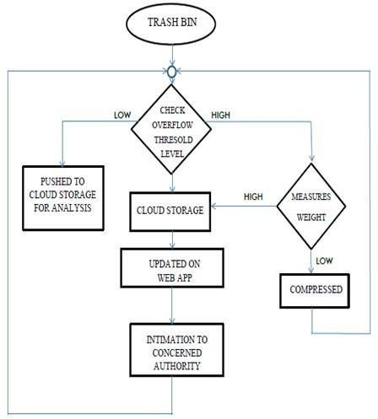

**5.2.Solution & Technical Architecture:**

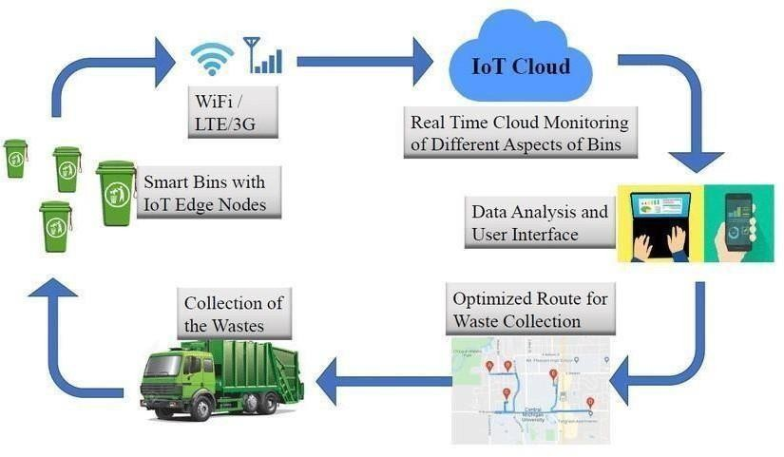

**5.3 User stories:**

|  |  |  |  |  |  |  |
| --- | --- | --- | --- | --- | --- | --- |
| **User Type** | **Functional Requirement (Epic)** | **User Story Number** | **User Story / Task** | **Acceptan cecriteria** | **Priority** | **Release** |
| Admin(who manages server) | Web server login | USN-1 | As a admin, I can able to track the truckdriver name,  id, contact number, location, and also the  location of the dustbin. | I can Manage anddirect workers through web server | High | Sprint-1 |
| Co-Admin | Login | USN-2 | As a co-admin I’ll monitor the workers, whether the work has been done properly, checking the availability of workers and also monitor the waste collected by the truck driver within the  scheduled time | I can monitorthe garbage binactivity | High | Sprint-1 |
| Customer (Web user) | User | USN-3 | As a user , I can able to raise queries to higher authorities about the maintenance and disposal of  waste | I can raise queries | Medium | Sprint-2 |
| Customer Care Executive | Worker | USN-4 | As a customer care executiveI will try to rectify the queries from customers by contacting coadmin. In case of emergency situation can be reported to Admin. | I can attend calls and respond people and solve their problems | High | Sprint-1 |

|  |  |  |  |  |  |  |
| --- | --- | --- | --- | --- | --- | --- |
| Truck driver | Worker | USN-5 | The truck driveris a  worker who has been assigned to collect the garbage and he have to report  to admin about when and where  and also the  timings , the garbage has been picked up according the dailyschedule. | I will do the work properly and report thedata at the scheduled time | High | Sprint1 |

# PROJECT PLANNING & SCHEDULING:

## Sprint Planning & Estimation:

|  |  |  |
| --- | --- | --- |
| PHASE | TITLE | DESCRIPTION |
| Ideation Phase | Literature Survey & | Literature survey on the |
| Information Gathering | selected project & gathering information by referring the, technical papers, research publications etc. |
| Prepare Empathy Map | Prepare Empathy Map Canvas to capture the user Pains & Gains, Prepare list of problem statements |

|  |  |  |
| --- | --- | --- |
|  | Ideation | List the by organizing the brainstorming session and prioritize the top 3 ideas based on the feasibility & importance. |
| Phase-1 | Proposed Solution | Prepare the proposed solution document, which includes the novelty, feasibility of idea, business model, social impact, scalability of solution, etc. |
| Problem Solution Fit | Prepare problem - solution fit document. |
| Solution Architecture | Prepare solution architecture document. |
| Phase-2 | Customer Journey | Prepare the customer journey maps to understand the user interactions & experiences with the application (entry to exit). |
| Functional Requirement | Prepare the functional and Nonfunctional requirement document. |
|  |  |
|  | Data Flow Diagrams | Draw the data flow diagrams and submit for review. |
| Technology Architecture | Prepare the technology architecture diagram. |
| Project planning phase | Prepare Milestone & Activity List | Prepare the milestones & activity list of the project. |

|  |  |  |
| --- | --- | --- |
| Project development phase | Project Development - Delivery of Sprint-1, 2, 3 & 4 | Develop & submit the developed code by testing it. |

* 1. **Sprint Delivery Schedule:**



**Functional**

**Task Point**

**(Epic)**

**Story Priority Members**

**-s**

**Team**

receive confirmation email once, I have enrolled for the project with team id and along with team members name.

Sprint- 1 Login

As a team member, I can login to

the IBM portal by entering email

1

Medium Ragupathi

password Sprint- As a team member, I can login to the 1 Ragupathi

Medium

2

IBM portal by entering email &

password

**SPRI NT**

|  |  |  |  |  |
| --- | --- | --- | --- | --- |
| Sprint- Registration | As a team lead, I can enrolled for the | 2 | High | Naveenraj |
| 1 | project by entering my email, password |  |  |  |
| and within that I can enter my team members | | | | |
| Sprint-1 | name and their email.  As a team lead, I will | 2 | High | Naveenraj |

|  |  |  |  |  |
| --- | --- | --- | --- | --- |
|  | & password |  |  |  |
| Sprint-2 | As a team member, I can login to the IBM portal by entering email & password | 1 | Medium | Saran |
| Sprint- 2 | As a team member, I can login to the IBM portal by entering email & | 1 | Medium | Naveenraj |

**Project Tracker, Velocity & Burndown Chart:**

|  |  |  |  |  |  |  |
| --- | --- | --- | --- | --- | --- | --- |
| **Sprint** | **Total Story Points** | **Duration** | **Sprint StartDate** | **Sprint End Date (Planned)** | **Story Points Completed (**  **Planned End**  **Date)** | **Sprint Release Date (Actual)** |
| Sprint-1 | 20 | 6 Days | 22 Oct 2022 | 27 Oct 2022 | 20 | 06 Nov 2022 |
| Sprint-2 | 20 | 6 Days | 31 Oct 2022 | 05 Nov 2022 | 30 | 07 Nov 2022 |
| Sprint-3 | 20 | 6 Days | 07 Nov 2022 | 12 Nov 2022 | 49 | 08 Nov 2022 |
| Sprint-4 | 20 | 6 Days | 14 Nov 2022 | 19 Nov 2022 | 50 | 09 ov 2022 |

# Reports from JIRA:

### Burnout Chart:

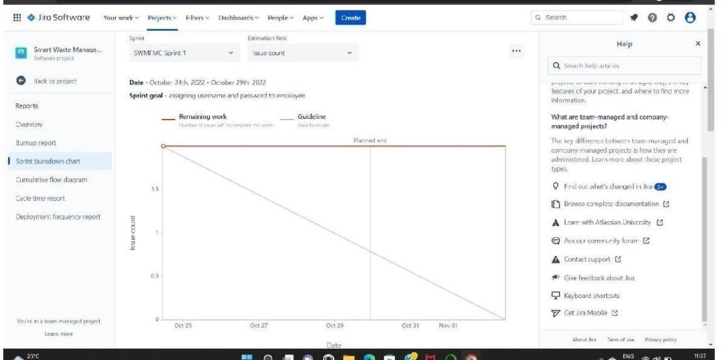

**Road map:**

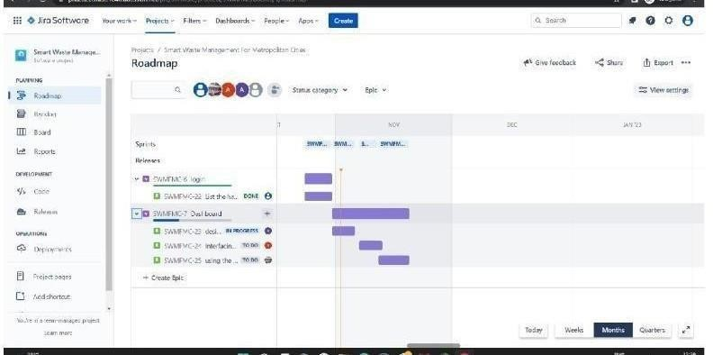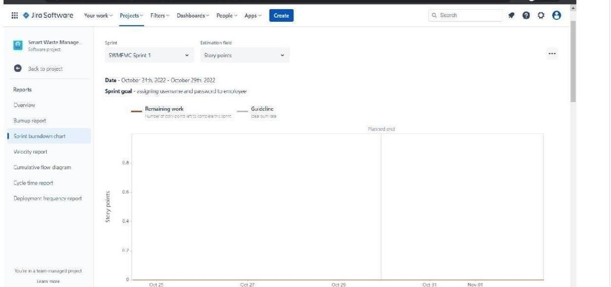

# CODING & SOLUTIONING:

* 1. **Feature 1- LOCATION TRACKER:**

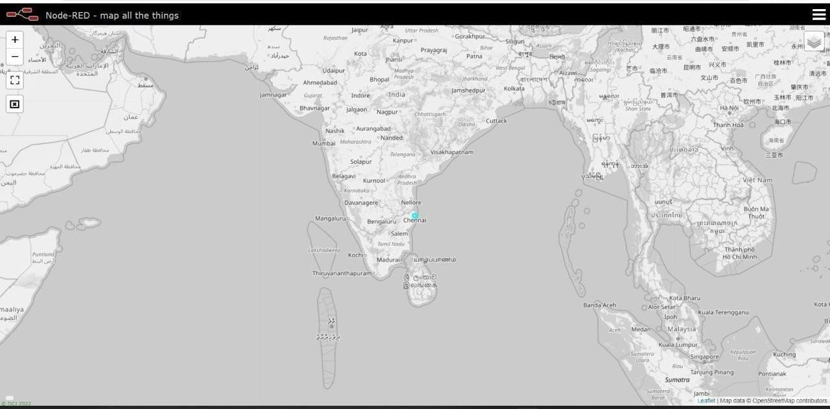

**7.2 Feature 2 – LIVE UPDATE ON COLLECTED DATA**

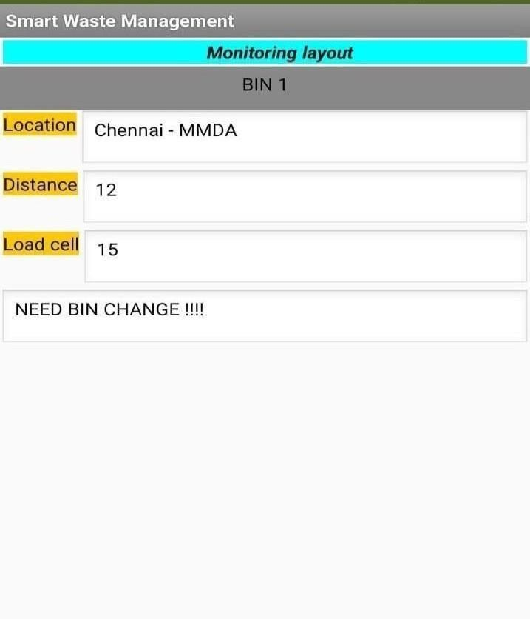

# Testing:

## Testcases:

|  |  |  |  |  |  |  |  |  |  |  |  |  |  |
| --- | --- | --- | --- | --- | --- | --- | --- | --- | --- | --- | --- | --- | --- |
| TEST CASE ID | FEATUR E TYPE | COM PO NENT | TEST SCENARI O | PR ER EQ UIS  ITE | STEPS TO EXEC UT  E | TEST DATA | EXPEC TED RESUL T | ACTU AL RESUL T | STAT U S | CO MM ENT S | TC FOR AUTO M ATIO N(  Y/N) | BU G ID | EXECUTED BY |
| LOGIN | FUNCTI | HOM | VERIFY |  | 1.ENT | https:// | L0gin | Workin | PASS | **Suc** |  |  | **PRASANTH M** |
| PAGE_TC | ONA L | E | THE USER | ER | 1 | page is | g as | **cess** |
| _001 |  | PAGE | IS ABLE | URL | 69.51.2 | visible | expecte | **ful** |
|  |  |  | TO SEE | AND | 0 |  | d |  |
|  |  |  | THE | CLICK | 4.219.3 |  |  |  |
|  |  |  | LOGIN/SI | GO | 0 |  |  |  |
|  |  |  | G | 2.VER | 106 |  |  |  |
|  |  |  | N UP | IFY |  |  |  |  |
|  |  |  | WEN | LOGI |  |  |  |  |
|  |  |  | USER | N/SI |  |  |  |  |
|  |  |  | CLICK ON | GN |  |  |  |  |
|  |  |  | MY | UP |  |  |  |  |
|  |  |  | ACCOUNT |  |  |  |  |  |
|  |  |  | BUTTON |  |  |  |  |  |

|  |  |  |  |  |  |  |  |  |  |  |  |  |  |
| --- | --- | --- | --- | --- | --- | --- | --- | --- | --- | --- | --- | --- | --- |
| LOGIN PAGE_TC  _002 | UI | HOM E PAGE | VERIFY THE USER IS ABLE TO SEE THE LOGIN/SI G  N UP WEN USER CLICK ON MY ACCOUNT BUTTON |  | 1. ENT ER URL AND CLICK GO 2.VER IFY LOGI N/SI GN UP  Eleme nts a.ID  text b o x  B  .  passw ord text box c..logi n butto n D.ne w user E.alre ady have an accou nt | https:// 1  69.51.2  0  4.219.3  0  106 | Applicat ion should show below UI  elemen t | Workin g as expecte d | PASS | Succ ess ful**l** |  |  | **SARAN S** |

|  |  |  |  |  |  |  |  |  |  |  |  |  |  |
| --- | --- | --- | --- | --- | --- | --- | --- | --- | --- | --- | --- | --- | --- |
| LOGIN PAGE_TC  _003 | FUNCTI ONA L | LOGI N PAGE | VERIFY THE USER IS ABLE TO SEE THE LOGIN/SI G  N UP WEN USER CLICK ON MY ACCOUNT BUTTON |  | 1.ent er url and click go 2.click on my accou nt 3.Ent er valid ID  4.Ent er valid passw ord 5.click on login | Id:1111  passwo r d:5678 | User should navigat e your home page. | Workin g as expecte d | PASS | Succ ess ful |  |  | **NAVEENRAJ K** |
|  |  |  |  |  | butto n |  |  |  |  |  |  |  |  |
| LOGIN | FUNCTI ONA | LOGI N | VERIFY |  | 1.ent er url | Id:1111 | Confirm | Workin | PASS | Succ ess |  |  | **RAGUPATHI R** |

|  |  |  |  |  |  |  |  |  |  |  |  |  |  |
| --- | --- | --- | --- | --- | --- | --- | --- | --- | --- | --- | --- | --- | --- |
| PAGE_TC_ 004 | L | PAGE | THE USER IS ABLE  TO SEE |  | and click go 2.click on my account 3.Enter valid ID 4.Enter valid password 5.click on login butvton | pass wor  d:56 | ation message sent | g as expecte d |  | ful |  |  |  |
| THE | 78 |
| LOGIN/SIG |  |
| N UP WEN |  |
| USER |  |
| CLICK ON |  |
| MY |  |
| ACCOUNT |  |
| BUTTON |  |
| LOGIN PAGE_TC_ 005 | UI | LOGIN PAGE | VERIFY THE USER IS ABLE TO SEE THE LOGIN/SIG N UP WEN  USER CLICK ON |  | 1.enter url and click go 2.click on my account 3.Enter valid ID  4.Enter valid | Id:1 111  pass wor d:56 78 | Confirm ation message sent | Workin g as expecte d | PASS | Success ful |  |  | **RAGUPATHI R** |
| MY | password |
| ACCOUNT | 5.click |
| BUTTON | on login |
|  | button |
| LOGIN | FUNCTIONA | LOGIN | VERIFY |  | 1.enter url and click go 2.click on my account 3.Enter valid ID 4.Enter valid password 5.click on login button | Id:1 | Custom | Workin | PASS | Success ful |  |  | **PRASANTH M** |
| PAGE_TC_ 006 | L | PAGE FOR ADMIN | THE USER IS ABLE TO SEE THE  LOGIN/SIG N UP WEN | 111  pass wor d:56 78 | er databas e is visible | g as expecte d |
|  |  |  | USER |  |  |  |
|  |  |  | CLICK ON |  |  |  |
|  |  |  | MY |  |  |  |
|  |  |  | ACCOUNT |  |  |  |
|  |  |  | BUTTON |  |  |  |

* 1. **User acceptance Testing:**

### Purpose of Document

The purpose of this document is to briefly explain the test coverage and open

issues of the[ProductName] project at the time of the release to User Acceptance Testing (UAT).

### 2. Defect Analysis

This report shows the number of resolved or closed bugs at each severity level, and how they were resolved

|  |  |  |  |  |  |
| --- | --- | --- | --- | --- | --- |
| **Resolution** | **Severity 1** | **Severity 2** | **Severity 3** | **Severity 4** | **Subtotal** |
| By Design | 10 | 4 | 2 | 3 | 20 |
| Duplicate | 1 | 0 | 3 | 0 | 4 |
| External | 2 | 3 | 0 | 1 | 6 |
| Fixed | 11 | 2 | 4 | 20 | 37 |

|  |  |  |  |  |  |
| --- | --- | --- | --- | --- | --- |
| Not Reproduced | 0 | 0 | 1 | 0 | 1 |
| Skipped | 0 | 0 | 1 | 1 | 2 |
| Won't Fix | 0 | 5 | 2 | 1 | 8 |
| Totals | 24 | 14 | 13 | 26 | 7 |

### Test Case Analysis:

This report shows the number of test cases that have passed, failed, and untested

|  |  |  |  |  |
| --- | --- | --- | --- | --- |
| **Section** | **Total Cases** | **Not Tested** | **Fai l** | **Pas s** |
| Print Engine | 7 | 0 | 0 | 7 |

|  |  |  |  |  |
| --- | --- | --- | --- | --- |
| Client Application | 51 | 0 | 0 | 51 |
| Security | 2 | 0 | 0 | 2 |
| Outsource Shipping | 3 | 0 | 0 | 3 |
| Exception Reporting | 9 | 0 | 0 | 9 |
| Final Report Output | 4 | 0 | 0 | 4 |
| Version Control | 2 | 0 | 0 | 2 |

# RESULTS:

* 1. **Performance Metrics:**

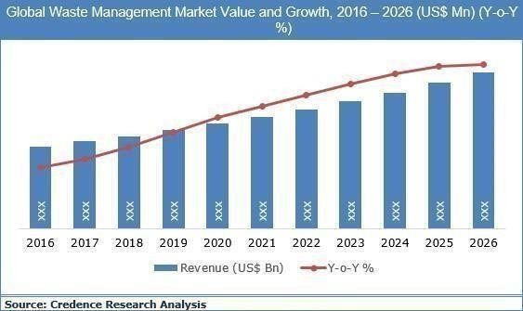

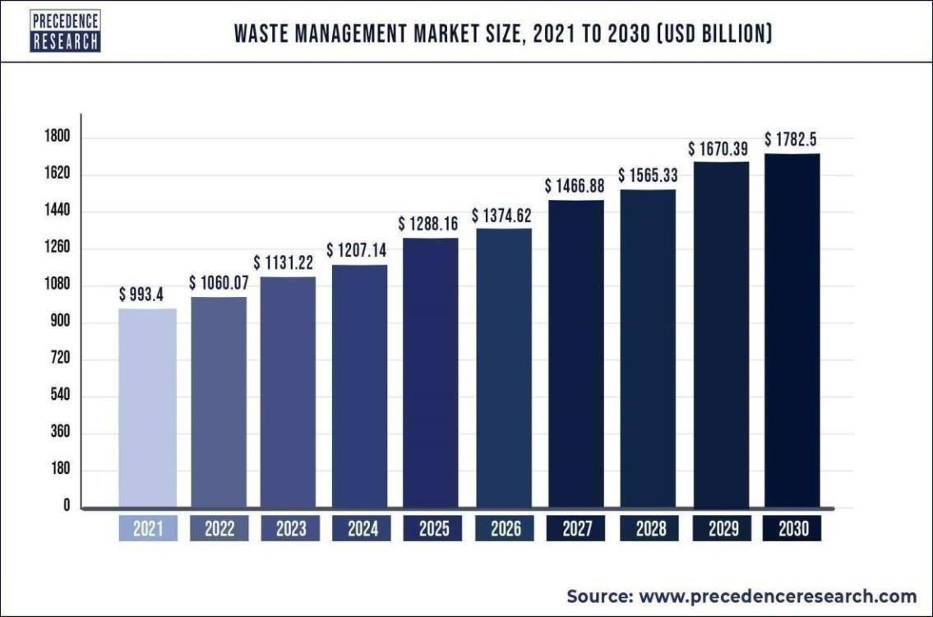

# ADVANTAGES & DISADVANTAGES

## ADVANTAGES:

* Reduction in Collection Cost
* No Missed Pickups
* Reduced Overflows
* Waste Generation Analysis
* CO2 Emission Reduction

## DISADVANTAGES:

* System requires a greater number of waste bins for separate waste collection as per population in the city.
* This results into high initial cost due to expensive smart dustbins compare to other methods. Sensor nodes used in the dustbins have limited memory size.

# CONCLUSION:

A Smart Waste Management system that is more effective than the one in use now is achievable by using sensors to monitor the filling of bins. Our conception of a "smart waste management system" focuses on monitoring waste management, offering intelligent technology for waste systems, eliminating human intervention, minimizing human time and effort, and producing a healthy and trash-free environment. The suggested approach can be implemented in smart cities where residents have busy schedules that provide little time for garbage management. If desired, the bins might be put into place in a metropolis where a sizable container would be able to hold enough solid trash for a single unit. The price might be high.

# FUTURE SCOPE:

There are several future works and improvements for the proposed system, including the following:

1. Change the system of user authentication and atomic lock of bins, which would aid in protecting the bin from damage or theft.
2. The concept of green points would encourage the involvement of residents or end users, making the idea successful and aiding in the achievement of collaborative waste management efforts, thus fulfilling the idea of Swachh Bharath.
3. Having case study or data analytics on the type and times waste is collected on different days or seasons, making bin filling predictable and removing the reliance on electronic components, and fixing the coordinates.
4. Improving the Server's and Android's graphical interfaces

# 13. Appendix:

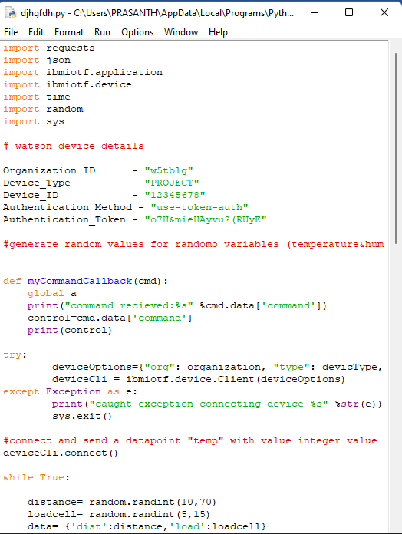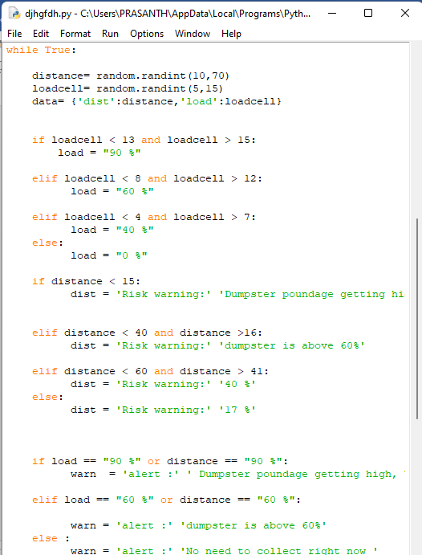

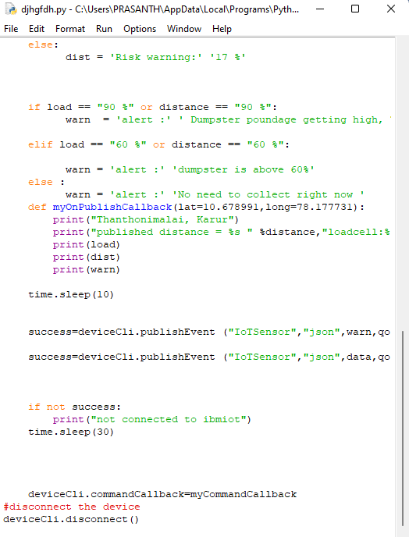

**GitHub Link:**

<https://github.com/IBM-EPBL/IBM-Project-4533-1658733989>